Network Simulations

- Install GNS3
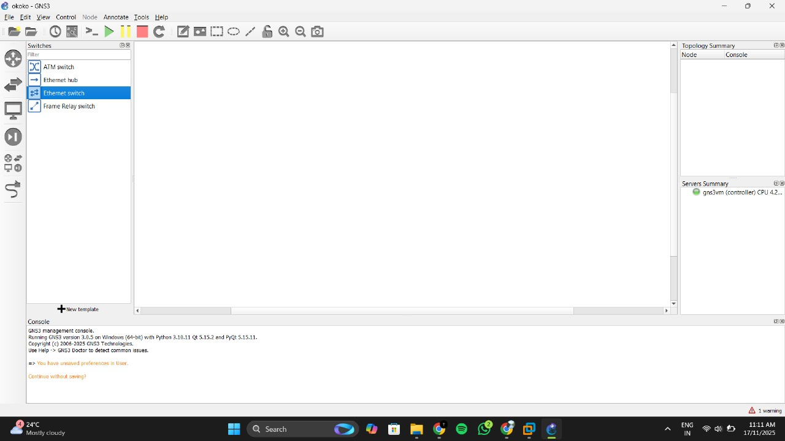

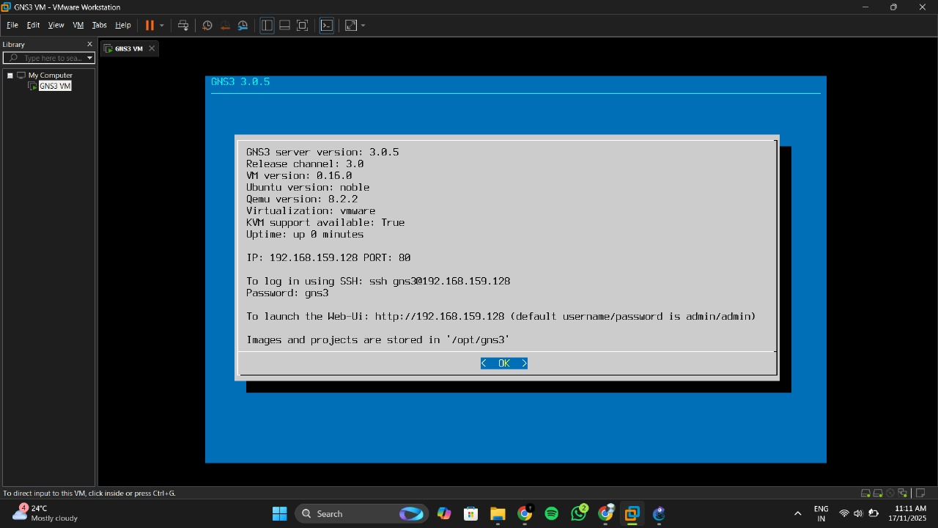

Topology 1 – Simple LAN:
• Devices: 2 PCs + 1 Switch
• Tasks: Connect PCs via switch, assign IPs in same subnet, verify with ping.
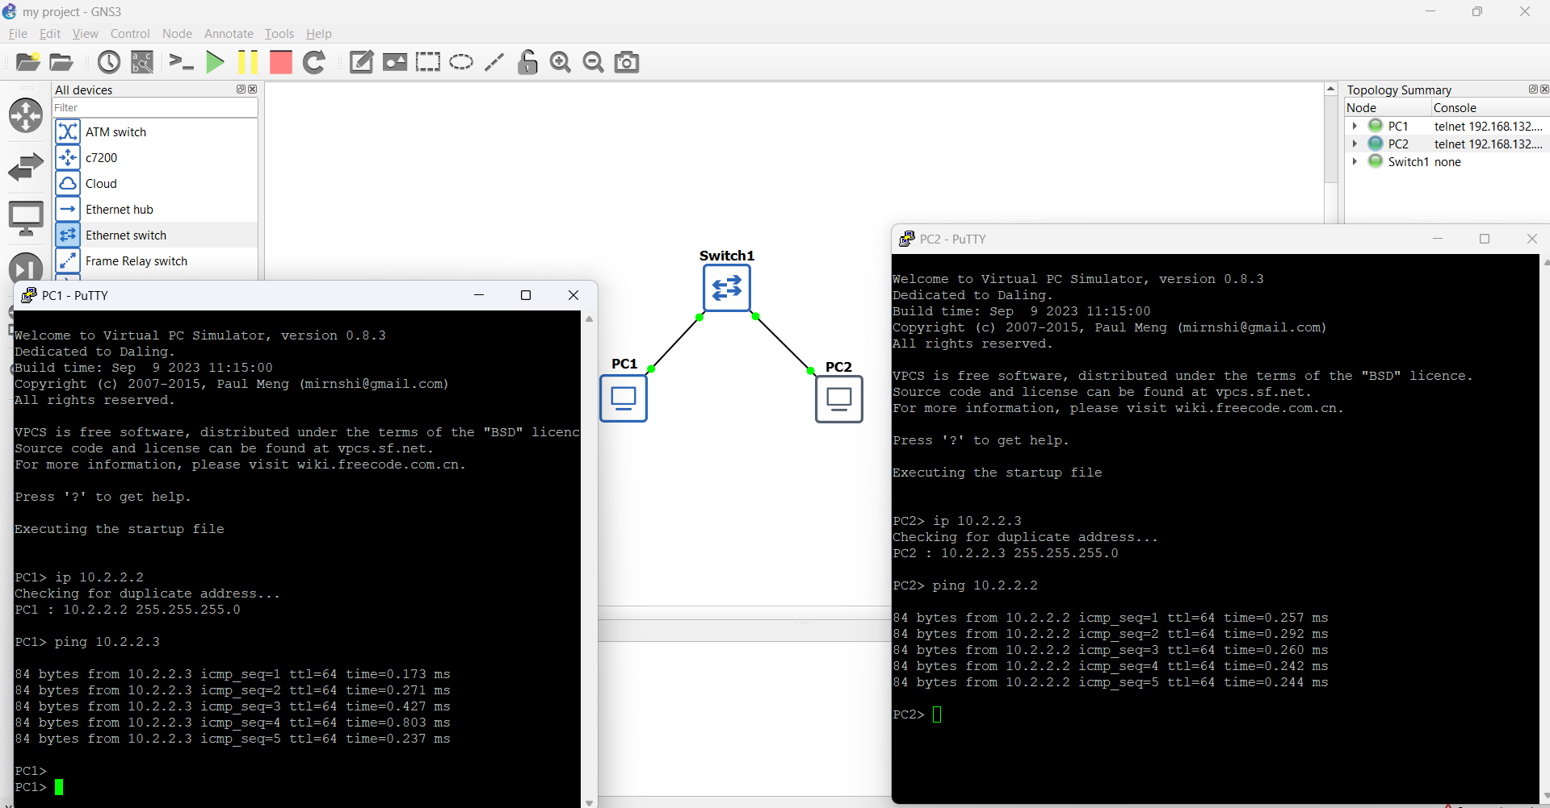

Topology 2 – Star Topology:

• Devices: 4 PCs + 1 Switch
• Tasks: Central switch with 4 PCs, assign IPs, verify connectivity.
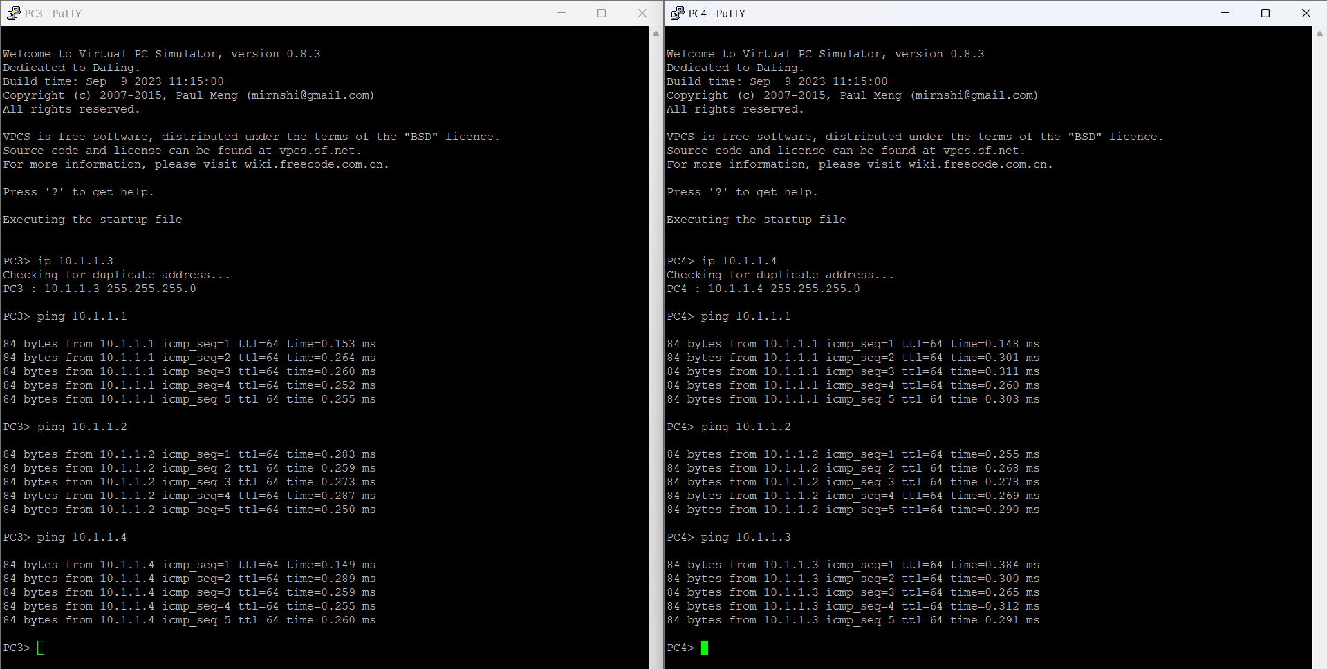

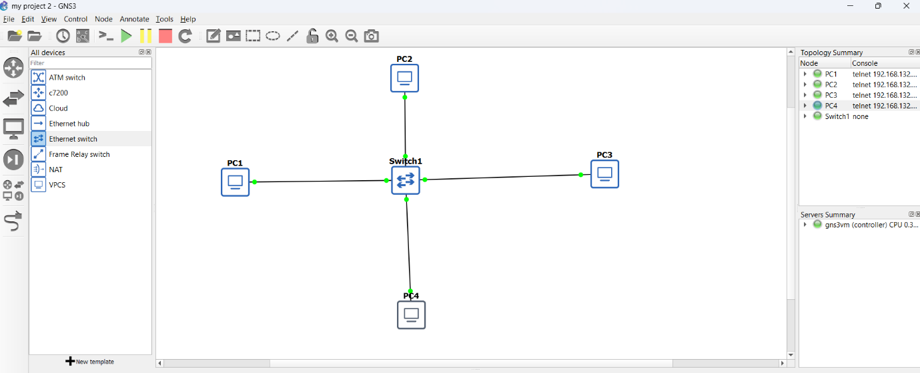

Topology 3 – Multi-Switch Mesh:
• Devices: 3 Switches + 3 PCs
• Tasks: SW1↔SW2↔SW3↔SW1, one PC per switch, assign IPs, verify with ping

